**PRACTICAL 1 :**

USING PACKET TRACER, CREATE A BASIC NETWORK OF TWO COMPUTERS USING APPROPRIATE

STEP 1:

From the left corner of the toolbar,select Selection on leftmost panel in bottom toolbar and then from righthand side panel select Selection on adjacent panel , drag and drop devices on screen refered in below table :

|  |  |  |
| --- | --- | --- |
| **Selection on leftmost panel** | **Selection on rightmost panel** | **ID** |
| End devices | PC-PT | PC0 |
| End devices | PC-PT | PC1 |
| Routers | 1841 | Router0 |

STEP 2:

From the leftmost panel , provide wired connection to both PC’s using copper cross – over wire.

STEP 3:

Click on PC0 and go to desktop for IP configuration.Provide IP address as “192.168.1.1” and default gateway as “192.168.1.10”

Now, click on PC1 and go to desktop for IP configuration.Provide IP address as “192.168.2.1” and default gateway as “192.168.2.10”.

STEP 4:

Click on Router0, go to config and select fastethernet0/0 . Now provide IP address as “192.168.1.10”.

Now select fastethernet0/1 and provide IP address as “192.168.2.10”.

STEP 5:

Pass the message and verify their connectivity with each other.

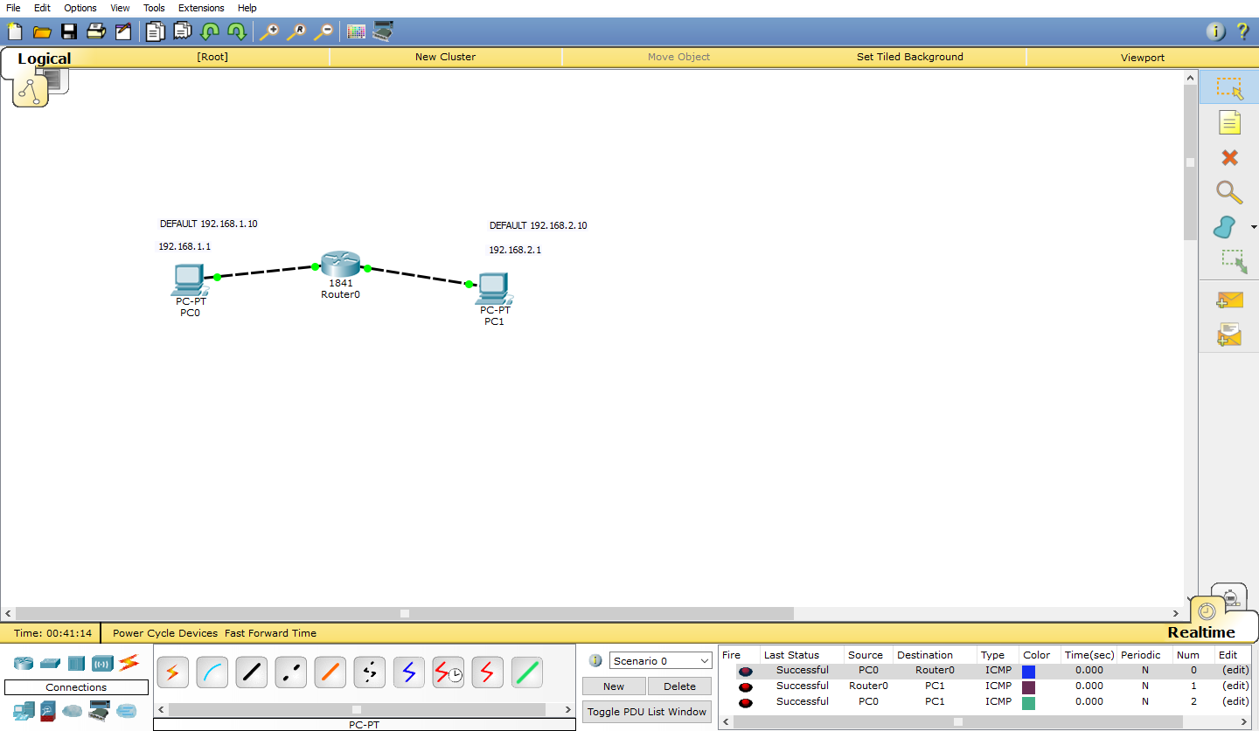

**Practical 2 :**

USING PACKET TRACER , CONNECT MULTIPLE (MINIMUM 6) COMPUTERS USING LAYER TO SWITCH

STEP 1:

From the left corner of the toolbar,select Selection on leftmost panel in bottom toolbar and then from righthand side panel select Selection on adjacent panel , drag and drop devices on screen refered in below table :

|  |  |  |
| --- | --- | --- |
| **Selection on leftmost panel** | **Selection on rightmost panel** | **ID** |
| End devices | PC-PT | PC0 |
| End devices | PC-PT | PC1 |
| End devices | PC-PT | PC2 |
| End devices | PC-PT | PC3 |
| End devices | PC-PT | PC4 |
| End devices | PC-PT | PC5 |
| Switches | 2950-24 | Switch0 |
| Switches | 2950-24 | Switch1 |

STEP 2:

From the leftmost panel , provide wired connection by using copper straight-through wire from PC0,PC1,PC2 to switch0 and PC3,PC4,PC5 to switch1. Now using copper cross-over wire connect both switches.

STEP 3:

Click on PC0 and go to desktop for IP configuration.Provide IP address as “192.168.1.1” and default gateway as “192.168.1.10”

Click on PC1 and go to desktop for IP configuration.Provide IP address as “192.168.1.2” and default gateway as “192.168.1.10”

Click on PC2 and go to desktop for IP configuration.Provide IP address as “192.168.1.3” and default gateway as “192.168.1.10”

Click on PC3 and go to desktop for IP configuration.Provide IP address as “192.168.1.4” and default gateway as “192.168.1.10”

Click on PC4 and go to desktop for IP configuration.Provide IP address as “192.168.1.5” and default gateway as “192.168.1.10”

Click on PC5 and go to desktop for IP configuration.Provide IP address as “192.168.1.6” and default gateway as “192.168.1.10”

STEP 4:

Pass the message and verify their connectivity with each other.

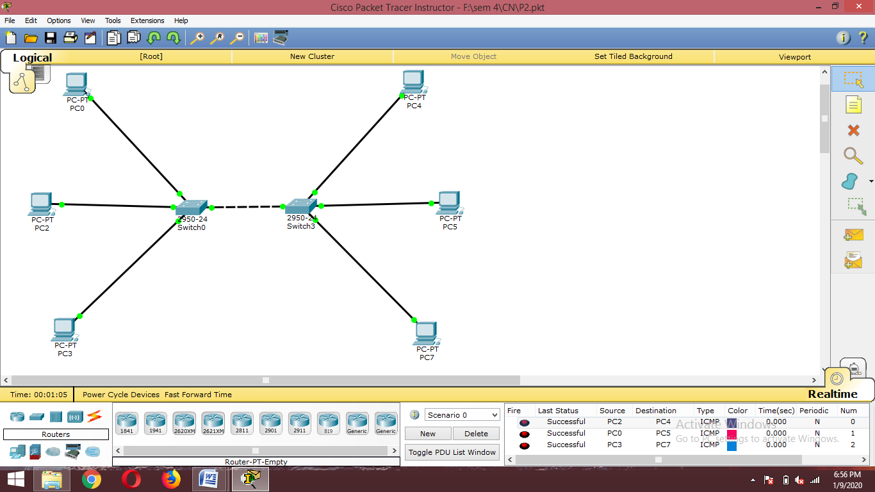

**PRATICAL 3 :**

USING PACKET TRACER, CONNECT A NETWORKMIN TRIANGULAR SHAPE WITH THREE LAYER, TWO SWITCHES AND EVERY SWITCH HAVE THREE COMPUTER. VERIFY THEIR CONNECTIVITY.

STEP 1:

From the left corner of the toolbar,select Selection on leftmost panel in bottom toolbar and then from righthand side panel select Selection on adjacent panel , drag and drop devices on screen refered in below table :

|  |  |  |
| --- | --- | --- |
| **Selection on leftmost panel** | **Selection on rightmost panel** | **ID** |
| End devices | PC-PT | PC0 |
| End devices | PC-PT | PC1 |
| End devices | PC-PT | PC2 |
| End devices | PC-PT | PC3 |
| End devices | PC-PT | PC4 |
| End devices | PC-PT | PC5 |
| End devices | PC-PT | PC6 |
| End devices | PC-PT | PC7 |
| End devices | PC-PT | PC8 |
| Switches | 2950-24 | Switch0 |
| Switches | 2950-24 | Switch1 |
| Switches | 2950-24 | Switch2 |

STEP 2:

From the leftmost panel , provide wired connection by using copper straight-through wire from PC0,PC1,PC2 to switch0 , PC3,PC4,PC5 to switch1 and PC6,PC7,PC8 to switch2. Now using copper cross-over wire provide connection between all three switches.

STEP 3:

Click on PC0 and go to desktop for IP configuration.Provide IP address as “192.168.1.1” and default gateway as “192.168.1.10”

Click on PC1 and go to desktop for IP configuration.Provide IP address as “192.168.1.2” and default gateway as “192.168.1.10”

Click on PC2 and go to desktop for IP configuration.Provide IP address as “192.168.1.3” and default gateway as “192.168.1.10”

Click on PC3 and go to desktop for IP configuration.Provide IP address as “192.168.1.4” and default gateway as “192.168.1.10”

Click on PC4 and go to desktop for IP configuration.Provide IP address as “192.168.1.5” and default gateway as “192.168.1.10”

Click on PC5 and go to desktop for IP configuration.Provide IP address as “192.168.1.6” and default gateway as “192.168.1.10”

Click on PC6 and go to desktop for IP configuration.Provide IP address as “192.168.1.7” and default gateway as “192.168.1.10”

Click on PC7 and go to desktop for IP configuration.Provide IP address as “192.168.1.8” and default gateway as “192.168.1.10”

Click on PC8 and go to desktop for IP configuration.Provide IP address as “192.168.1.9” and default gateway as “192.168.1.10”

STEP 4:

Pass the message and verify their connectivity with each other.

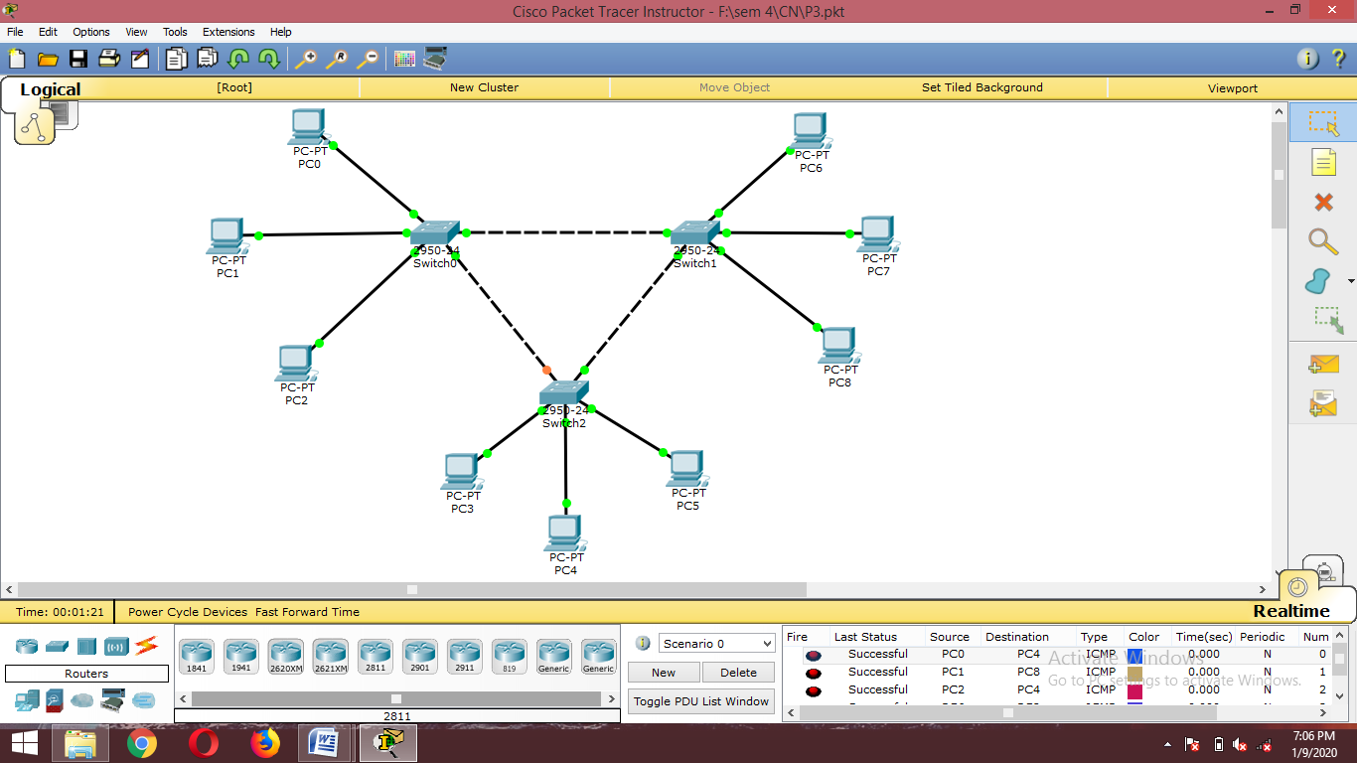

**PRACTICAL 4 :**

USING PACKET TRACER, CREATE A WIRELESS NETWORK OF MULTIPLE PC’S USING APPROPRIATE ACESS POINT.

STEP 1:

From the left corner of the toolbar,select Selection on leftmost panel in bottom toolbar and then from righthand side panel select Selection on adjacent panel , drag and drop devices on screen refered in below table :

|  |  |  |
| --- | --- | --- |
| **Selection on leftmost panel** | **Selection on rightmost panel** | **ID** |
| End devices | PC-PT | PC0 |
| End devices | Laptop-PT | Laptop0 |
| End devices | SMARTPHONE-PT | Smartphone0 |
| Wireless devices | AccessPoint-PT | AccessPoint0 |

STEP 2:

Click on PC0 in Physical tab view Physical view of CPU. Switch OFF the CPU and then remove the PT-HEADPHONE module from CPU and then add WMP300N module to CPU and Switch ON the CPU.

Click on Laptop0 in Physical tab view Physical view of Laptop. Switch OFF the Laptop and then remove the PT-HEADPHONE module from Laptop and then add WMP300N module to Laptop and Switch ON the Laptop.

STEP 3:

Click on PC0 and go to desktop for IP configuration.Provide IP address as “192.168.1.1” and default gateway as “192.168.1.10”

Click on Laptop1 and go to desktop for IP configuration.Provide IP address as “192.168.1.2” and default gateway as “192.168.1.10”

STEP 4:

Click On AccessPoint0 select Config.Click on Port 1. Assign SSID=Network, and in frame Authentication select WPA2-PSK assign Pass Phrase of your choice to AccessPoint0.

STEP 5:

Click On PC0,select Desktop and click on Wireless Connections.Now Click On Connect.SSID of AccessPoint0 will appear in list of available connections. Click On SSID of AccessPoint0 ie Netwok and then Click on Connect.After clicking on Connect a dialog will appear asking for Pass Phrase. Enter the Pass Phrase and then Click On Connect.

Now Click On Laptop0,select Desktop and click on Wireless Connections.Now Click On Connect.SSID of AccessPoint0 will appear in list of available connections. Click On SSID of AccessPoint0 ie Netwok and then Click on Connect.After clicking on Connect a dialog will appear asking for Pass Phrase. Enter the Pass Phrase and then Click On Connect.

STEP 6:

Click On Smartphone0 and select Config.Click on Wireless0.Enter SSID of AccessPoint0 ie Network and then in Authentication frame select WPA2-PSK and enter Pass Phrase.

STEP 7:

Pass the message and verify their connectivity with each other.

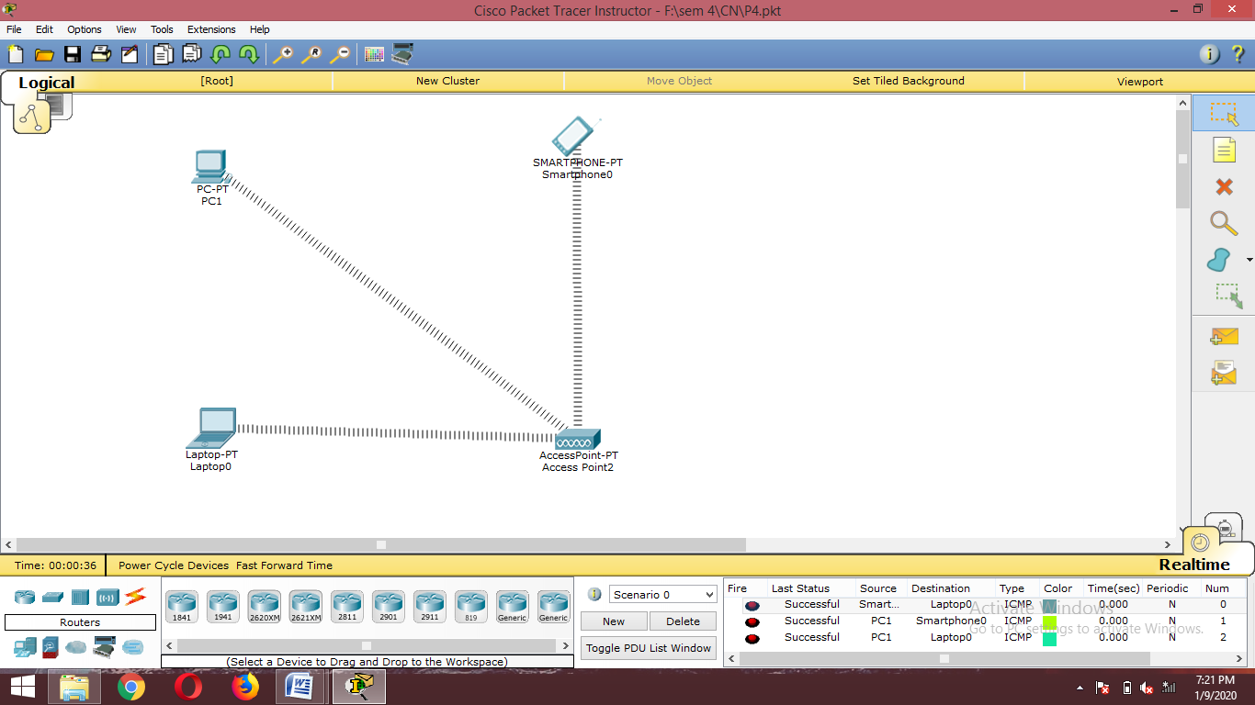

**PRACTICAL 5 :**

USING WIRESHARK NETWORK ANALYSER SET THE FILTER FOR TCMP,TCP,HTTP,UDP,FTP AND PERFORM THE RESPECTIVE PROTOCOL TRANSACTIONS TO SHOW OR PROVE THAT NETWORK ANALYSER IS WORKING.

STEP 1:

From the left corner of the toolbar,select Selection on leftmost panel in bottom toolbar and then from righthand side panel select Selection on adjacent panel , drag and drop devices on screen refered in below table :

|  |  |  |
| --- | --- | --- |
| **Selection on leftmost panel** | **Selection on rightmost panel** | **ID** |
| End devices | PC-PT | PC0 |
| End devices | PC-PT | PC1 |
| End devices | Laptop-PT | Laptop0 |
| End devices | SMARTPHONE-PT | Smartphone0 |
| Wireless devices | AccessPoint-PT | AccessPoint0 |
| Switches | 2950-24 | Switch0 |
| Routers | 1841 | Router0 |

STEP 2:

From the leftmost panel , provide wired connection by using copper straight-through wire from PC1,AccessPoint0, Router0 to switch0.

STEP 3:

Click on PC0 in Physical tab view Physical view of CPU. Switch OFF the CPU and then remove the PT-HEADPHONE module from CPU and then add WMP300N module to CPU and Switch ON the CPU

Click on Laptop0 in Physical tab view Physical view of CPU. Switch OFF the CPU and then remove the PT-HEADPHONE module from CPU and then add WMP300N module to CPU and Switch ON the CPU

STEP 4:

Click on PC0 and go to desktop for IP configuration.Provide IP address as “192.168.1.1” and default gateway as “192.168.1.10”

Click on PC1 and go to desktop for IP configuration.Provide IP address as “192.168.1.2” and default gateway as “192.168.1.10”

Click on Laptop1 and go to desktop for IP configuration.Provide IP address as “192.168.1.3” and default gateway as “192.168.1.10”

STEP 5:

Click On AccessPoint0 select Config.Click on Port 1. Assign SSID=Network, and in frame Authentication select WPA2-PSK assign Pass Phrase of your choice to AccessPoint0.

STEP 6:

Click On PC0,select Desktop and click on Wireless Connections.Now Click On Connect.SSID of AccessPoint0 will appear in list of available connections. Click On SSID of AccessPoint0 ie Netwok and then Click on Connect.After clicking on Connect a dialog will appear asking for Pass Phrase. Enter the Pass Phrase and then Click On Connect.

Now Click On Laptop0,select Desktop and click on Wireless Connections.Now Click On Connect.SSID of AccessPoint0 will appear in list of available connections. Click On SSID of AccessPoint0 ie Netwok and then Click on Connect.After clicking on Connect a dialog will appear asking for Pass Phrase. Enter the Pass Phrase and then Click On Connect.

STEP 7:

Click On Smartphone0 and select Config.Click on Wireless0.Enter SSID of AccessPoint0 ie Network and then in Authentication frame select WPA2-PSK and enter Pass Phrase.

STEP 8:

Pass the message and verify their connectivity with each other.

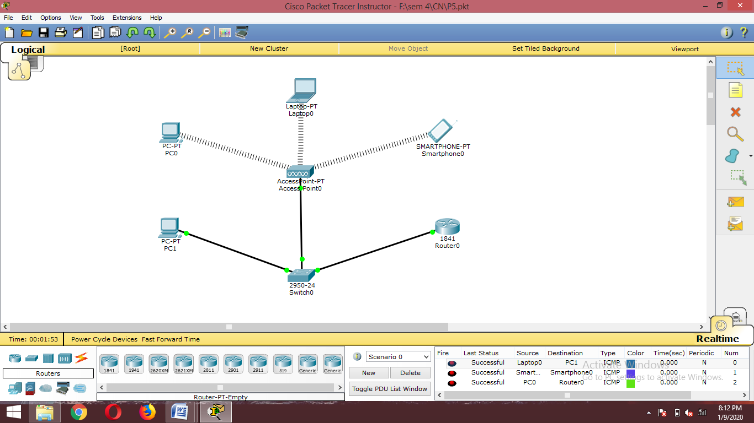

**PRACTICAL 6 :**

USING CISCO PACKET TRACER CREATE A CONNECTION BETWEEN ROUTER , SWITCH AND PC’S

STEP 1:

From the left corner of the toolbar,select Selection on leftmost panel in bottom toolbar and then from righthand side panel select Selection on adjacent panel , drag and drop devices on screen refered in below table :

|  |  |  |
| --- | --- | --- |
| **Selection on leftmost panel** | **Selection on rightmost panel** | **ID** |
| End devices | PC-PT | PC0 |
| End devices | PC-PT | PC1 |
| End devices | PC-PT | PC2 |
| End devices | PC-PT | PC3 |
| Switches | 2950-24 | Switch0 |
| Switches | 2950-24 | Switch1 |
| Routers | 1841 | Router0 |
| Routers | 1841 | Router1 |

STEP 2:

Click on Router0 in Physical view. Switch OFF the Router and then add WIC-2T module to Router and Switch ON.

Click on Router1 in Physical view. Switch OFF the Router and then add WIC-2T module to Router and Switch ON.

STEP 3:

From the leftmost panel , provide wired connection by using copper serial DTE wire from Router0 to Router1,serial 0/0

STEP 4:

Click on PC0 and go to desktop for IP configuration.Provide IP address as “10.0.0.1” and default gateway as “10.0.0.10”

Click on PC1 and go to desktop for IP configuration.Provide IP address as “10.0.0.2” and default gateway as “10.0.0.10”

Click on PC2 and go to desktop for IP configuration.Provide IP address as “20.0.0.10” and default gateway as “20.0.0.20”

Click on PC3 and go to desktop for IP configuration.Provide IP address as “20.0.0.11” and default gateway as “20.0.0.20”

Step 5:

Click on Router0, go to config and select fastethernet0/0 . Now provide IP address as “10.0.0.10” and switch on the port status.

Now select serial0/0 and provide IP address as “192.168.1.10” and switch on the port status.

Click on Router1, go to config and select fastethernet0/0 . Now provide IP address as “20.0.0.20” and switch on the port status.

Now select serial0/0 and provide IP address as “192.168.1.11” and switch on the port status.

STEP 6:

Click on Router0, go to config and select RIP . Now add the following networks:

10.0.0.0 , 20.0.0.0 , 192.168.1.0

Click on Router1, go to config and select RIP . Now add the following networks:

10.0.0.0 , 20.0.0.0 , 192.168.1.0

STEP 7:

Pass the message and verify their connectivity with each other.

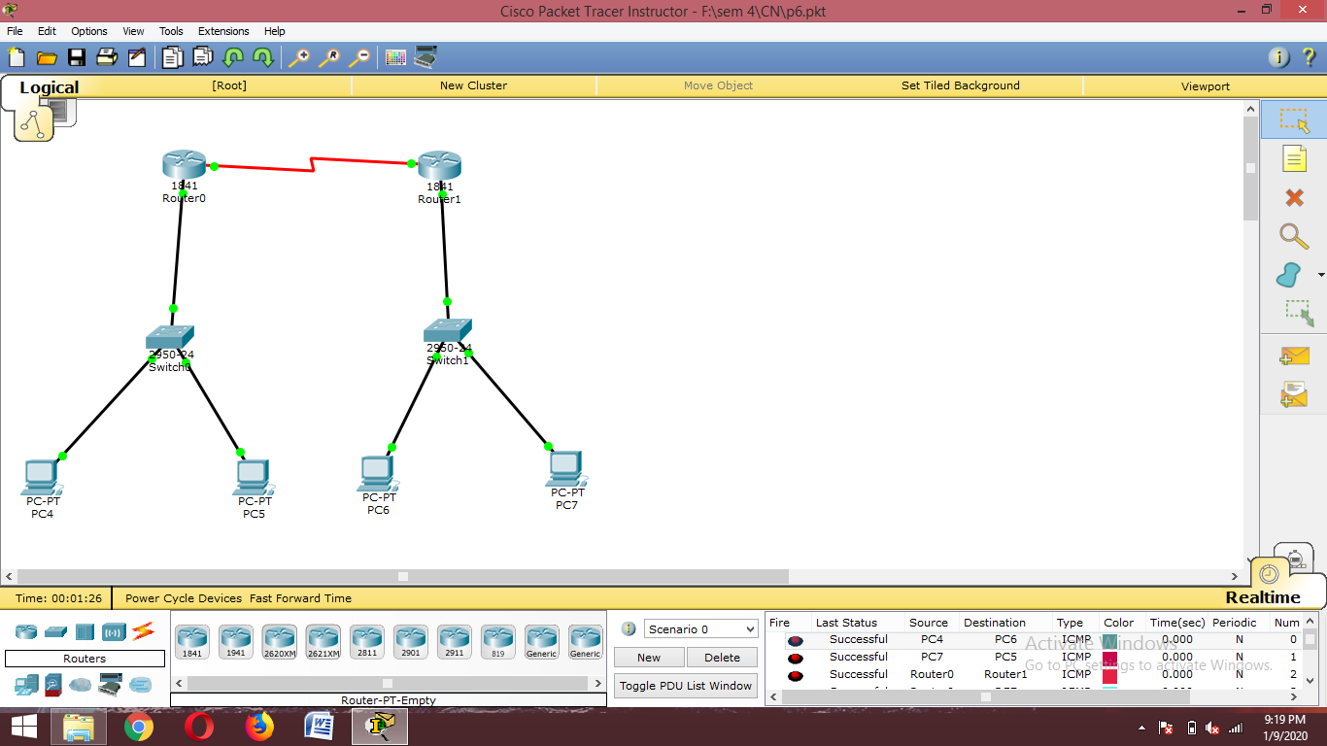

**PRACTICAL 7 :**

USING LINUX TERMINAL OR WINDOWS CMD EXECUTE THE FOLLOWING NETWORK COMMAND AND NOTE THE OUTPUT

Commands are as follows:

(a)PING.

(b)tracert.

(c)NetStat .

(d)arp.

(e)ipconfig.

(a)PING

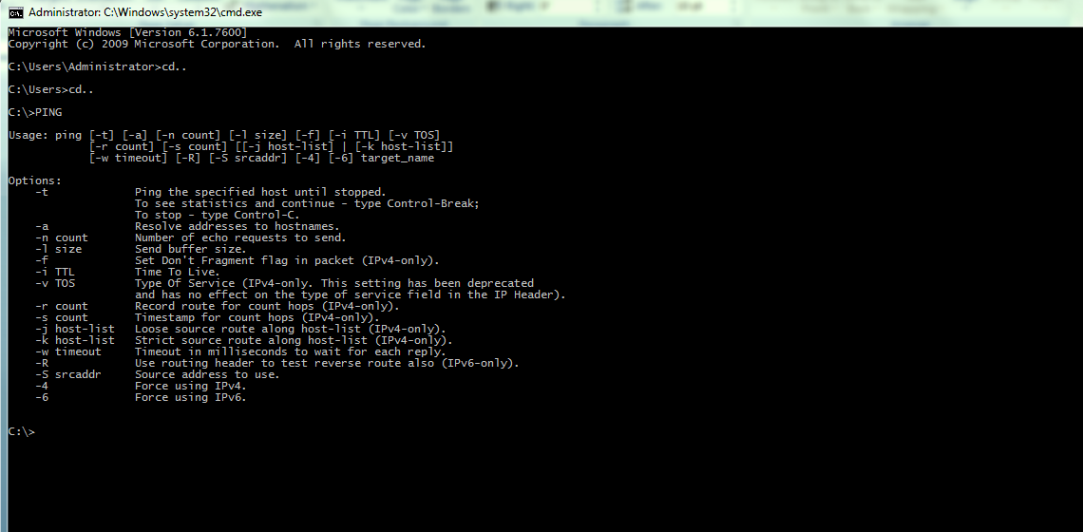

(b)tracert

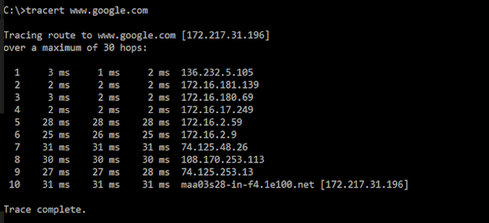

(c)netstat

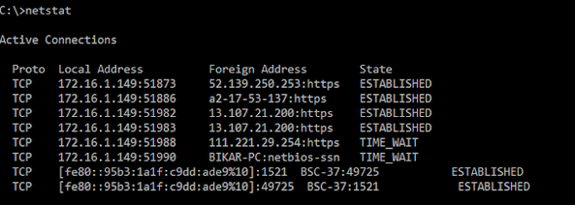

(d)arp

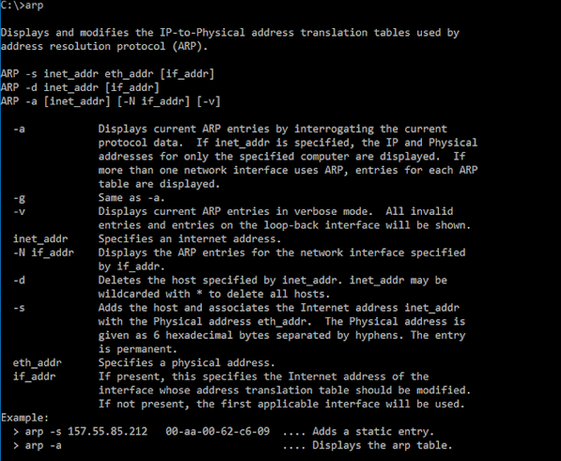

(e)ipconfig

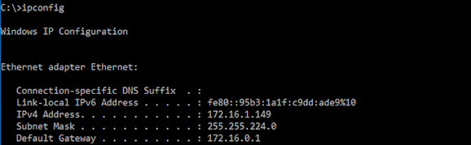

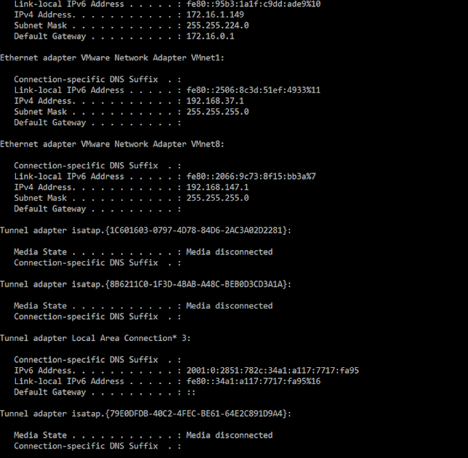

**PRACTICAL 8 :**

ESTABLISH CONNECTION BETWEEN SERVER AND PC WITH THE HELP OF ROUTER AND SWITCH

STEP 1:

From the left corner of the toolbar,select Selection on leftmost panel in bottom toolbar and then from righthand side panel select Selection on adjacent panel , drag and drop devices on screen refered in below table :

|  |  |  |
| --- | --- | --- |
| **Selection on leftmost panel** | **Selection on rightmost panel** | **ID** |
| End devices | PC-PT | PC0 |
| Switches | 2950-24 | Switch0 |
| Routers | 1841 | Router0 |
| End devices | Server-PT | Server0 |

STEP 2:

From the leftmost panel , provide wired connection by using copper straight-through wire from PC0 to switch0 and from switch0 to router0. Now using copper cross-over wire connect router0 to server0.

STEP 3:

Click on PC0 and go to desktop for IP configuration. Provide IP address as “192.168.1.1” and default gateway as “192.168.1.10”

Click on Router0, go to config and select fastethernet0/0 . Now provide IP address as “192.168.1.1” and switch on the port status.

Click on Router0, go to config and select fastethernet0/1 . Now provide IP address as “10.0.0.10” and switch on the port status.

Click on Server0 and go to desktop for IP configuration. Provide IP address as “10.0.0.1” and default gateway as “10.0.0.10”

STEP 4:

Pass the message and verify their connectivity with each other.

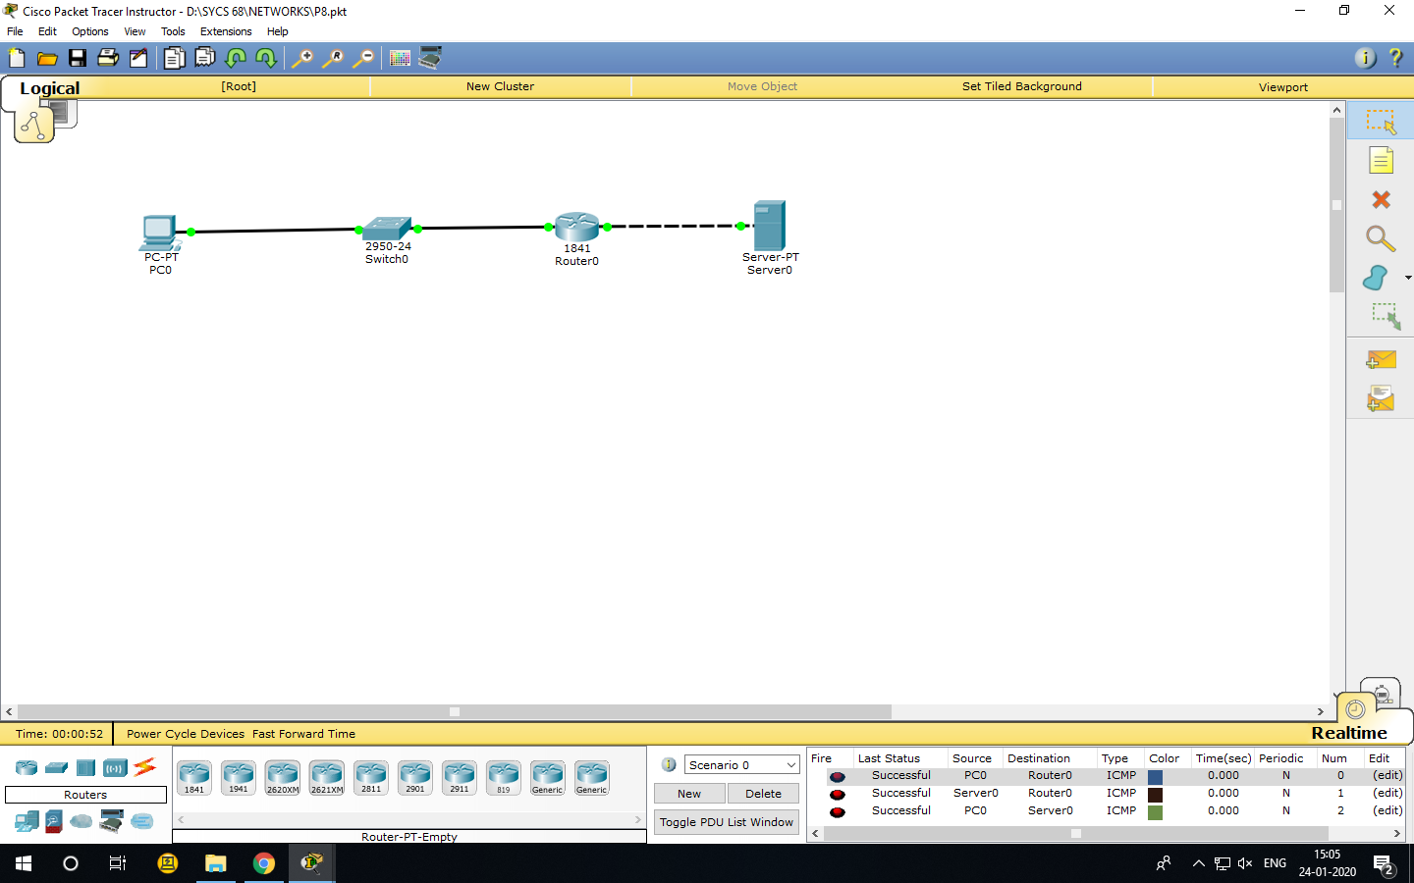

**PRACTICAL 9 :**

PERFORM MESH TOPOLOGY NETWORK CONNECTION USING CISCO PACKET TRACER

STEP 1:

From the left corner of the toolbar, select Selection on leftmost panel in bottom toolbar and then from right and side panel select Selection on adjacent panel , drag and drop devices on screen referred in below table :

|  |  |  |
| --- | --- | --- |
| **Selection on leftmost panel** | **Selection on rightmost panel** | **ID** |
| End devices | PC-PT | PC0 |
| End devices | PC-PT | PC1 |
| End devices | PC-PT | PC2 |
| End devices | PC-PT | PC3 |
| Switches | 2950-24 | Switch0 |
| Switches | 2950-24 | Switch1 |
| Switches | 2950-24 | Switch2 |
| Switches | 2950-24 | Switch3 |

STEP 2:

From the leftmost panel , provide wired connection by using copper straight-through wire from PC0 to switch0, PC1 to switch1, PC2 to switch2 and PC3 to switch3. Now using copper cross-over wire connect all switches with each other.

STEP 3:

Click on PC0 and go to desktop for IP configuration. Provide IP address as “192.168.0.1” and default gateway as “192.168.1.10”

Click on PC1 and go to desktop for IP configuration .Provide IP address as “192.168.0.2” and default gateway as “192.168.1.10”

Click on PC2 and go to desktop for IP configuration. Provide IP address as “192.168.0.3” and default gateway as “192.168.1.10”

Click on PC3 and go to desktop for IP configuration .Provide IP address as “192.168.0.4” and default gateway as “192.168.1.10”

STEP 4:

Pass the message and verify their connectivity with each other.

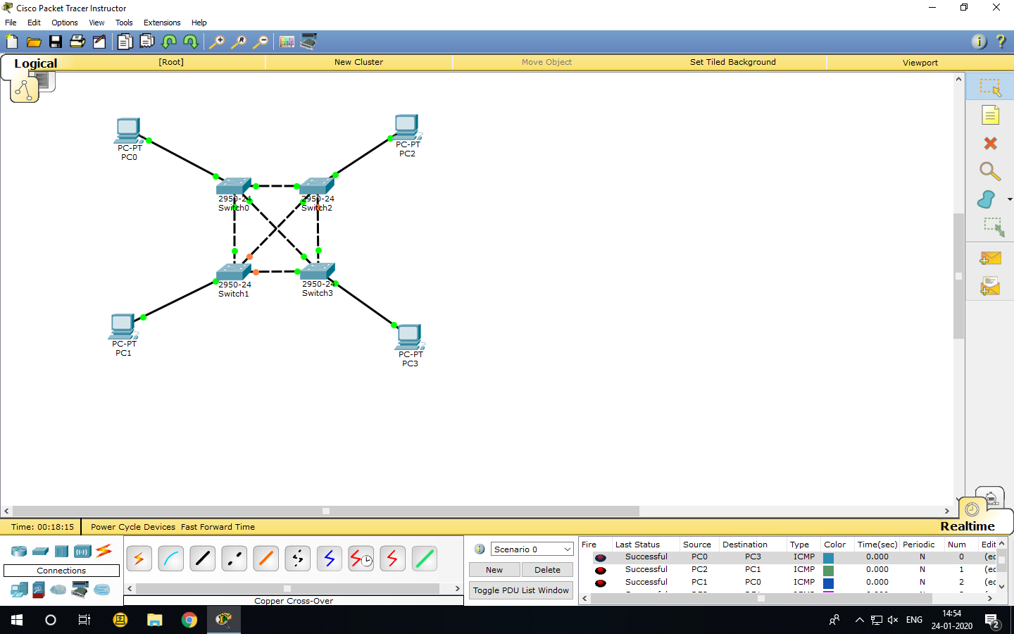

**Practicle -10**

**Aim:-Using DHCP Server configuration and a switch create a communication network between 2 generic PC’c and 2 laptop.**

**Step-1:-**

From the left corner of the toolbar, select Selection on leftmost panel in bottom toolbar and then from right and side panel select Selection on adjacent panel , drag and drop devices on screen referred in below table :

|  |  |  |
| --- | --- | --- |
| **Selection on leftmost panel** | **Selection on rightmost panel** | **ID** |
| End devices | PC-PT | PC0 |
| End devices | PC-PT | PC1 |
| End devices | Laptop-PT | Laptop0 |
| End devices | Laptop-PT | Laptop1 |
| Switches | 2950-24 | Switch0 |
| End devices | Server-pt | Server0 |

STEP 2:

From the leftmost panel , provide wired connection by using copper straight-through wire from PC0 to switch0, PC1 to switch0, Laptop0 to switch0 , Laptop1 to switch0 and Server0 to Switch0.

STEP 3:

Click on Server0 and go to desktop for IP configuration. Provide IP address as “192.168.0.1” .

Now go to Services and click on DHCP. Default Gateway as “192.168.0.1” and provide DNS server

As “10.0.0.1” . Now ON the services from top-most-right.

Click on PC0 and go to desktop for IP configuration. Select DHCP option .

Click on PC1 and go to desktop for IP configuration. Select DHCP option .

Click on Laptop0 and go to desktop for IP configuration. Select DHCP option .

Click on Laptop1 and go to desktop for IP configuration. Select DHCP option .

STEP 4:

Pass the message and verify their connectivity with each other.

